**BO YU PROJECT**

**Logcall page**

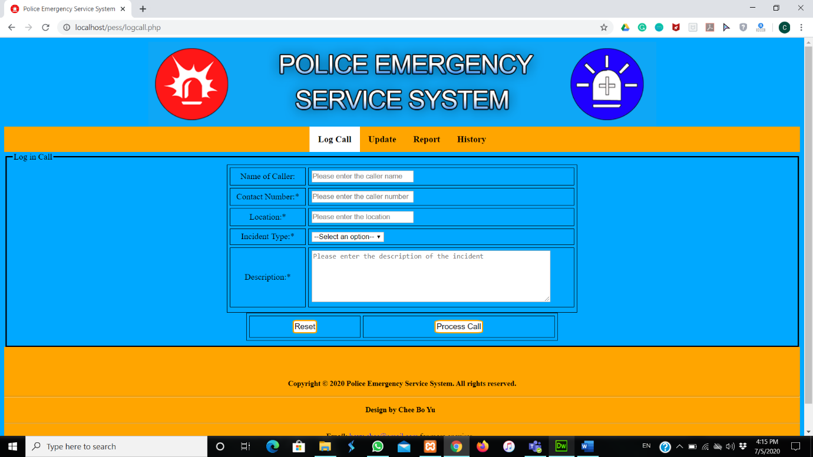

**Logcall page footer:**

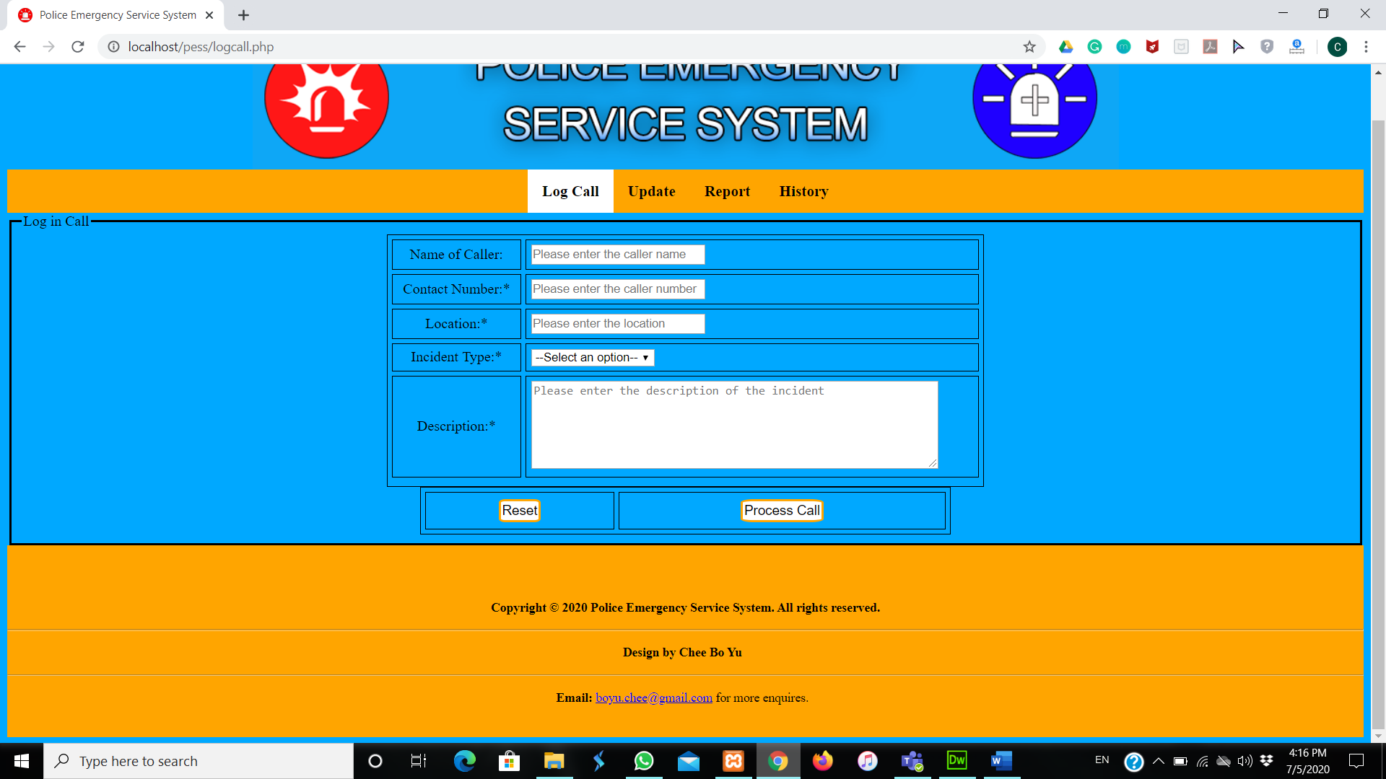

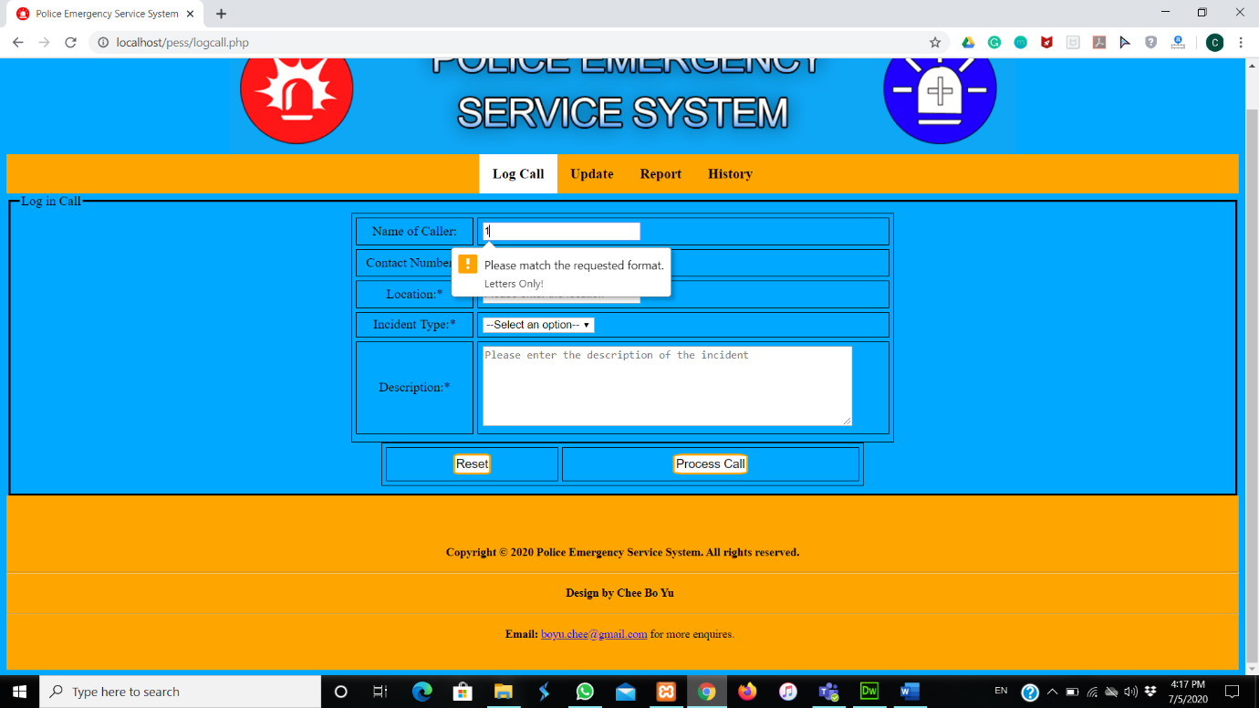**Validation for Name of Caller in logcall page:**

**Validation for Contact Number in logcall page:**

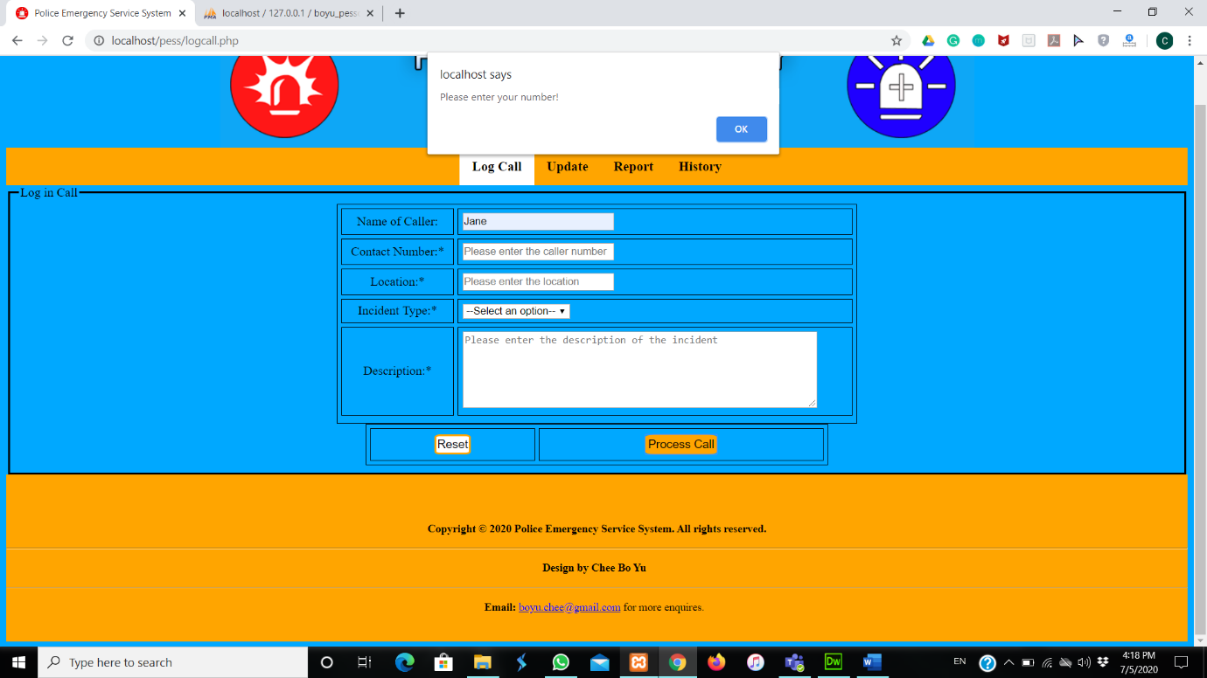

**Validation for Location in logcall page:**

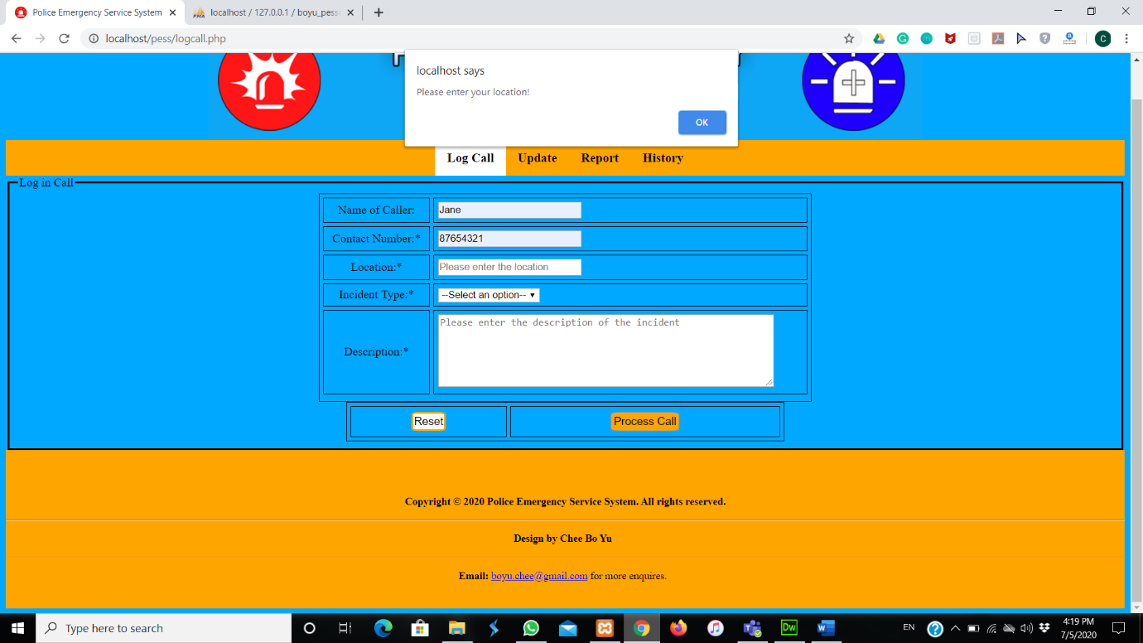

**Validation for Incident Type in logcall page:**

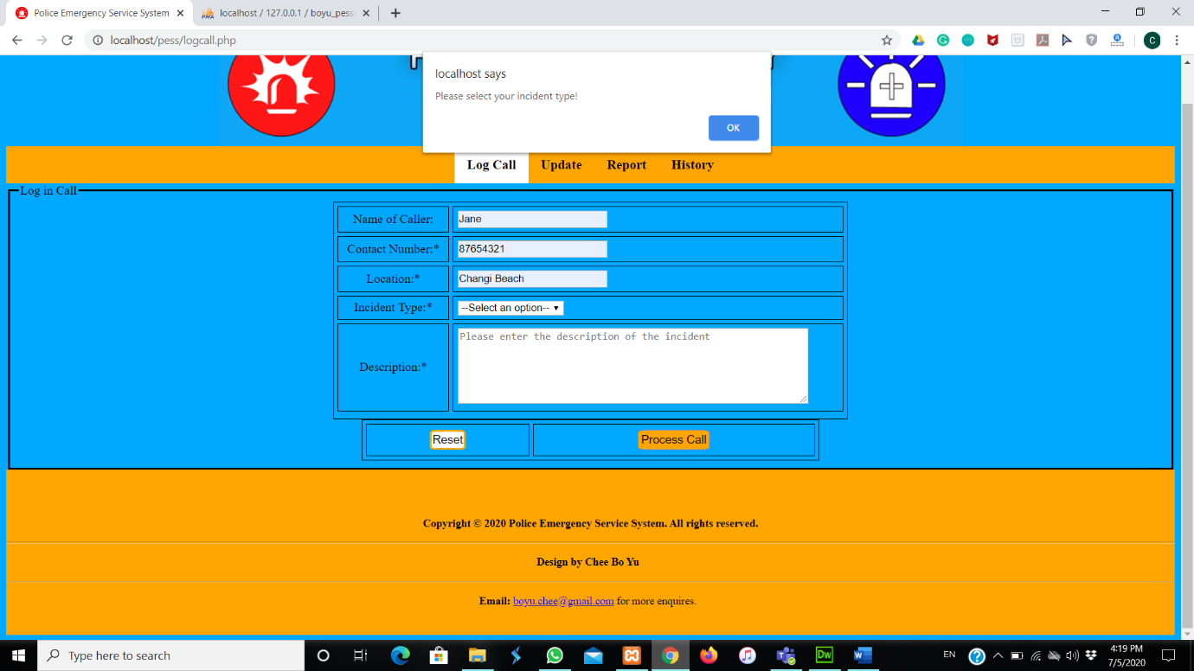

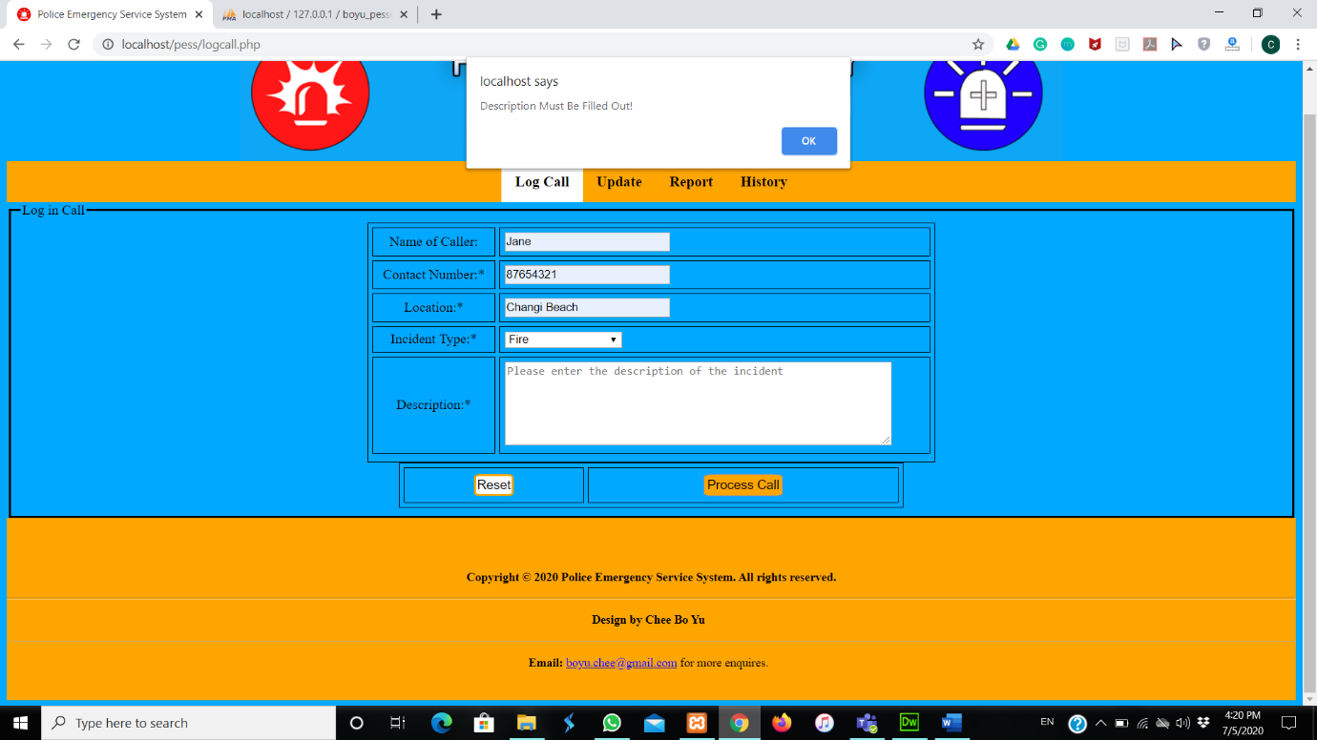**Validation for Description in logcall page:**

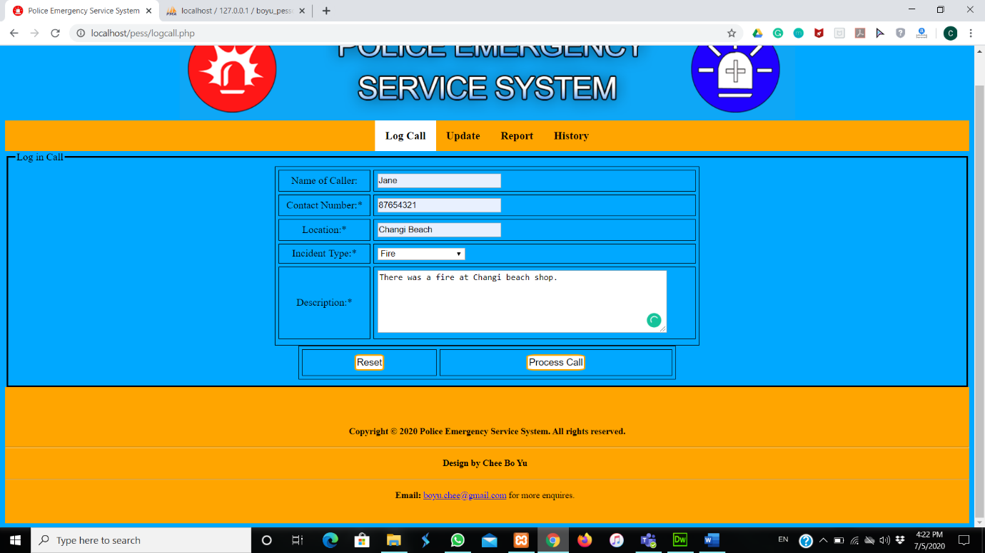**Entering details in Logcall page:**

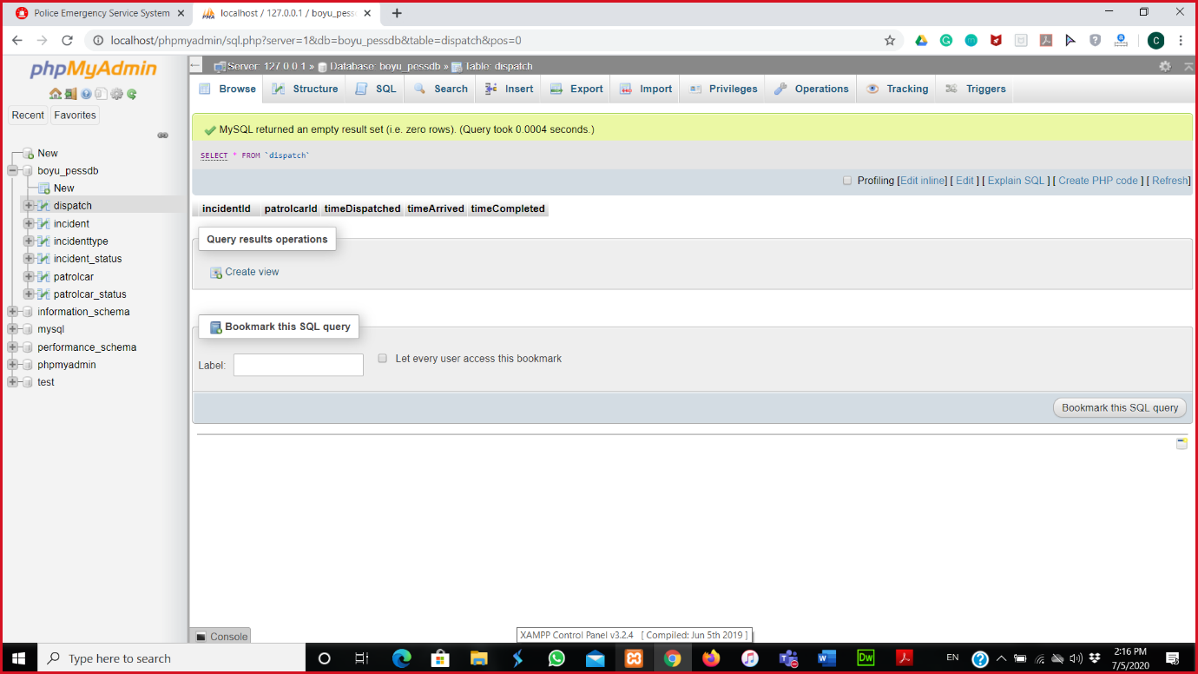**Database of dispatch browse:**

**Database of incident browse:**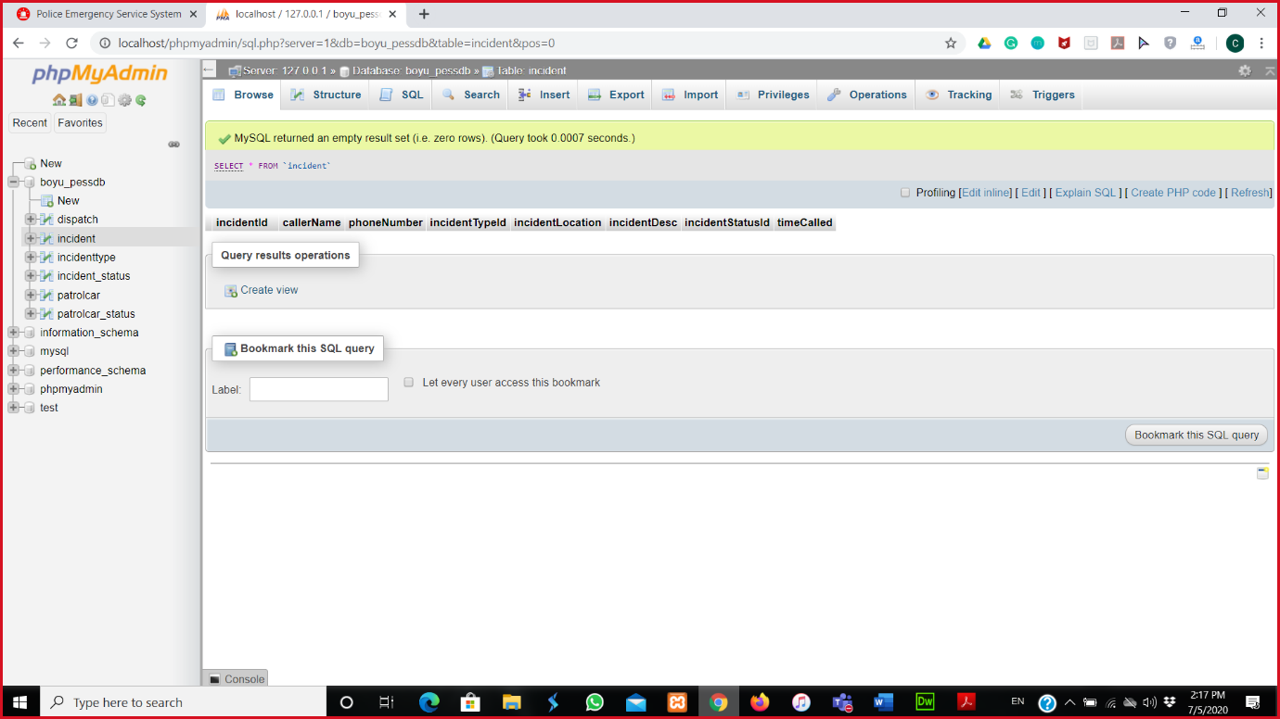

**Dispatch page:**

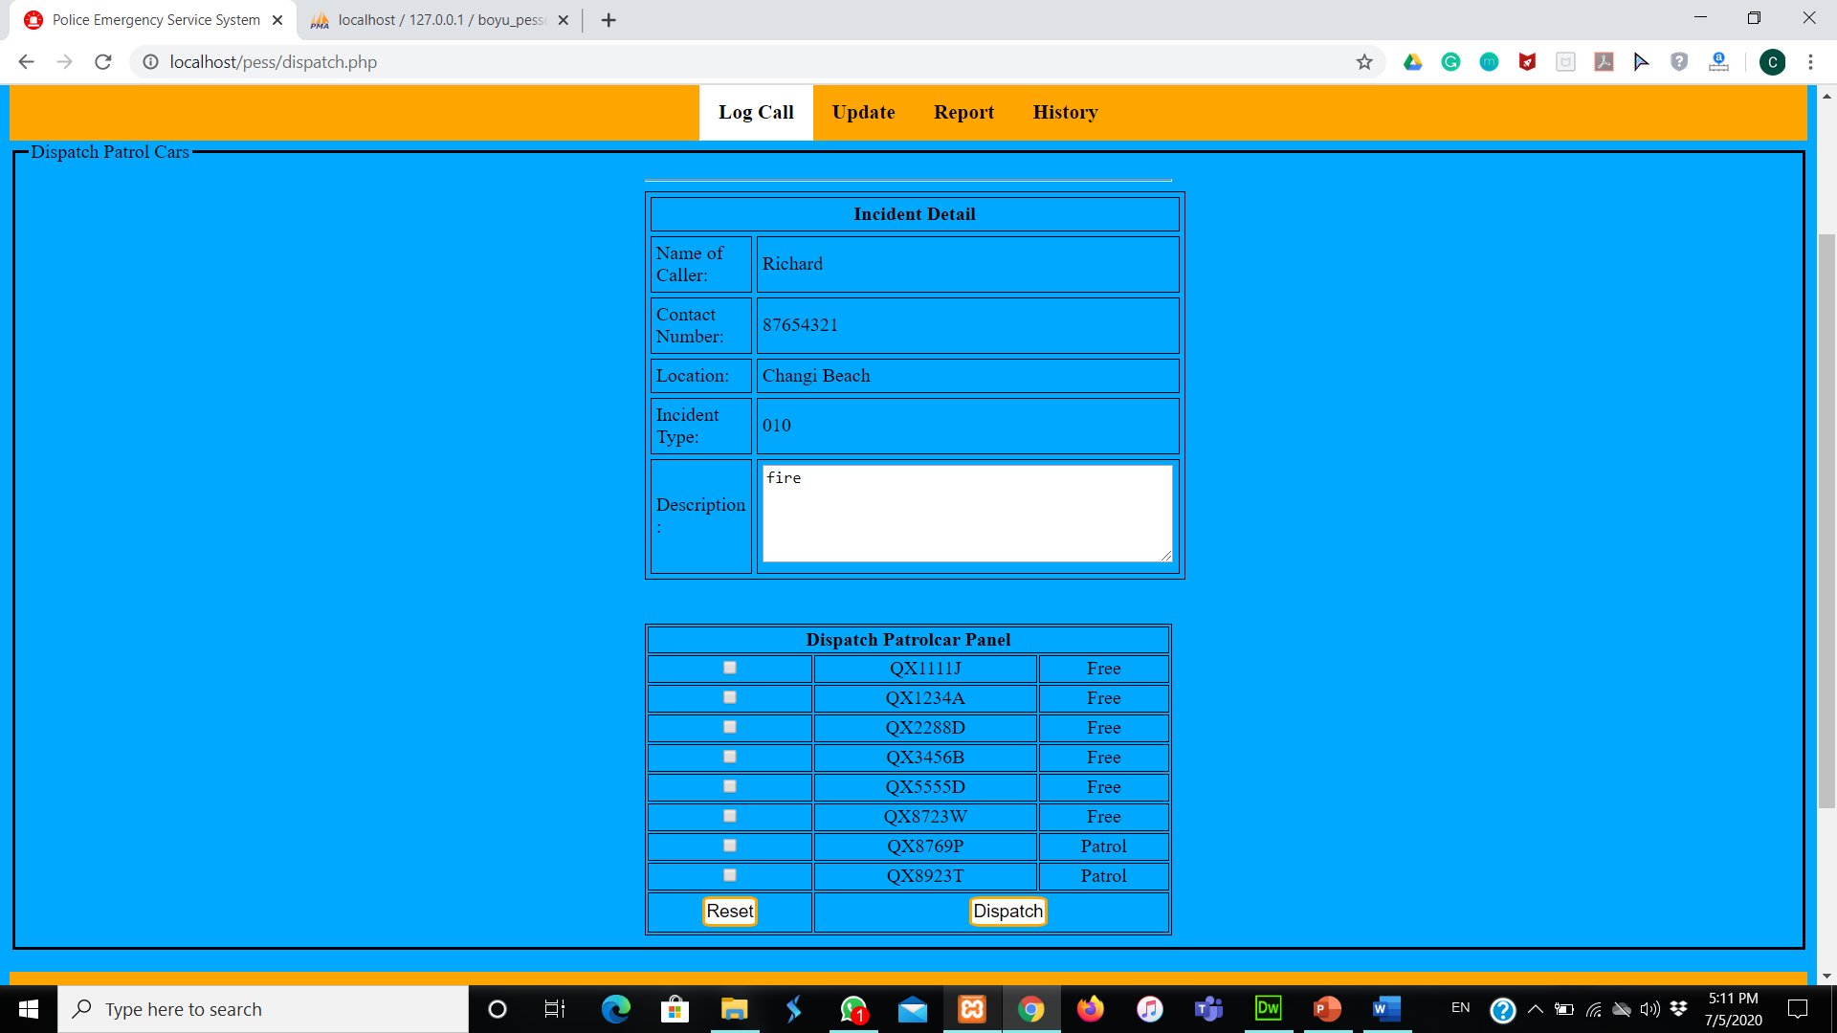

**Ticking the box for dispatching patrol car:**

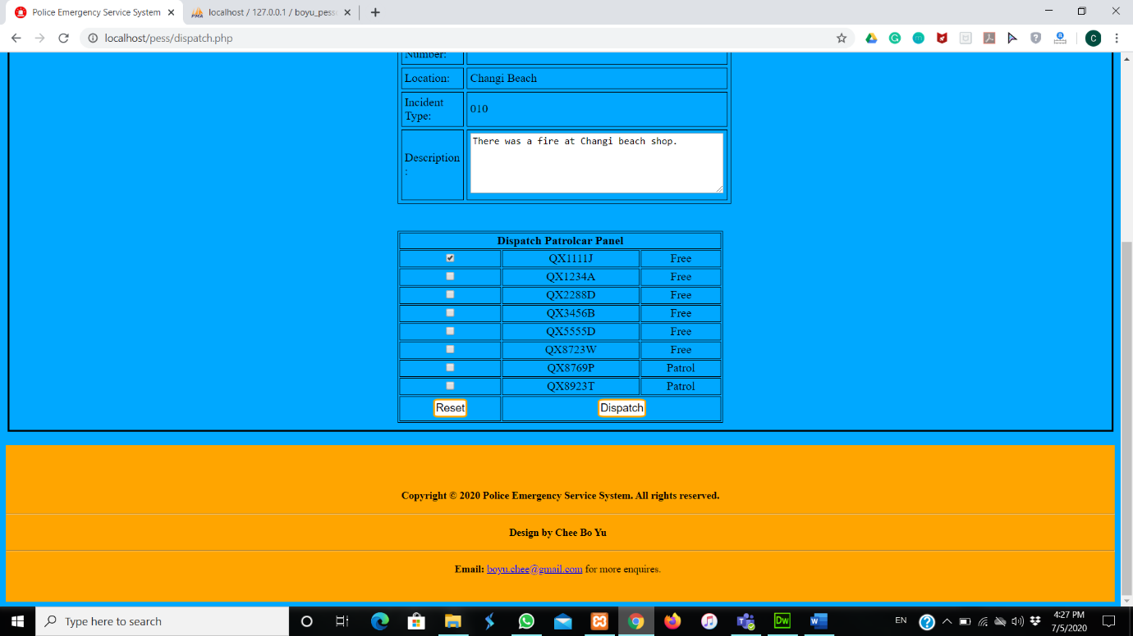

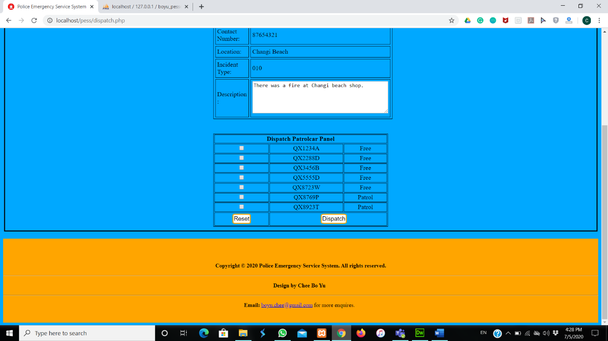**The patrol car that has been tick will disappear:**

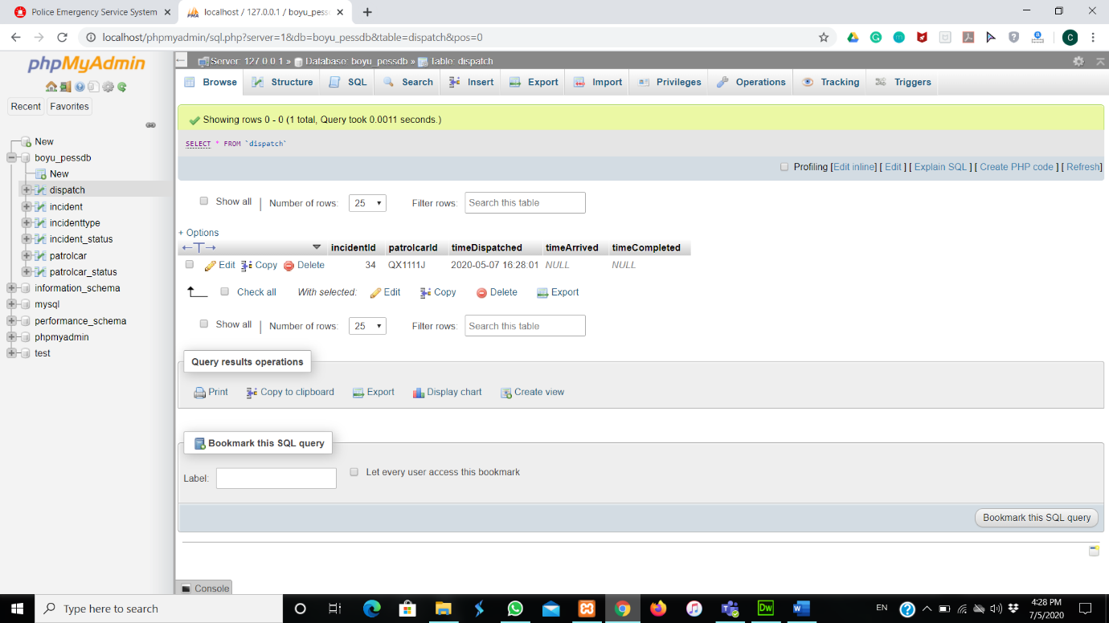**Database of Dispatch browse:**

**Database of Incident browse:**

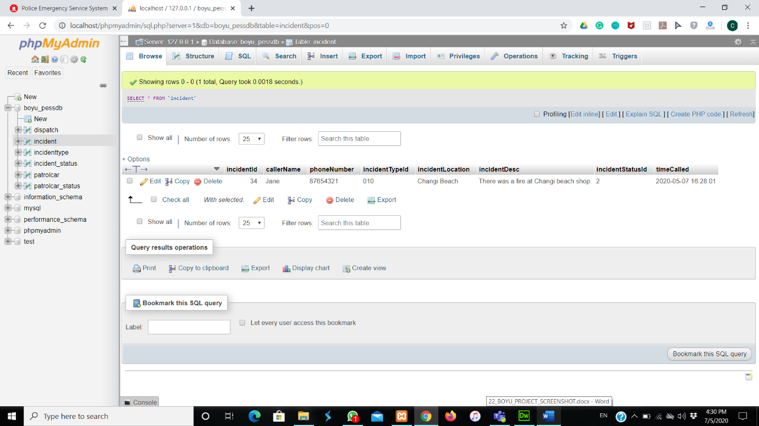

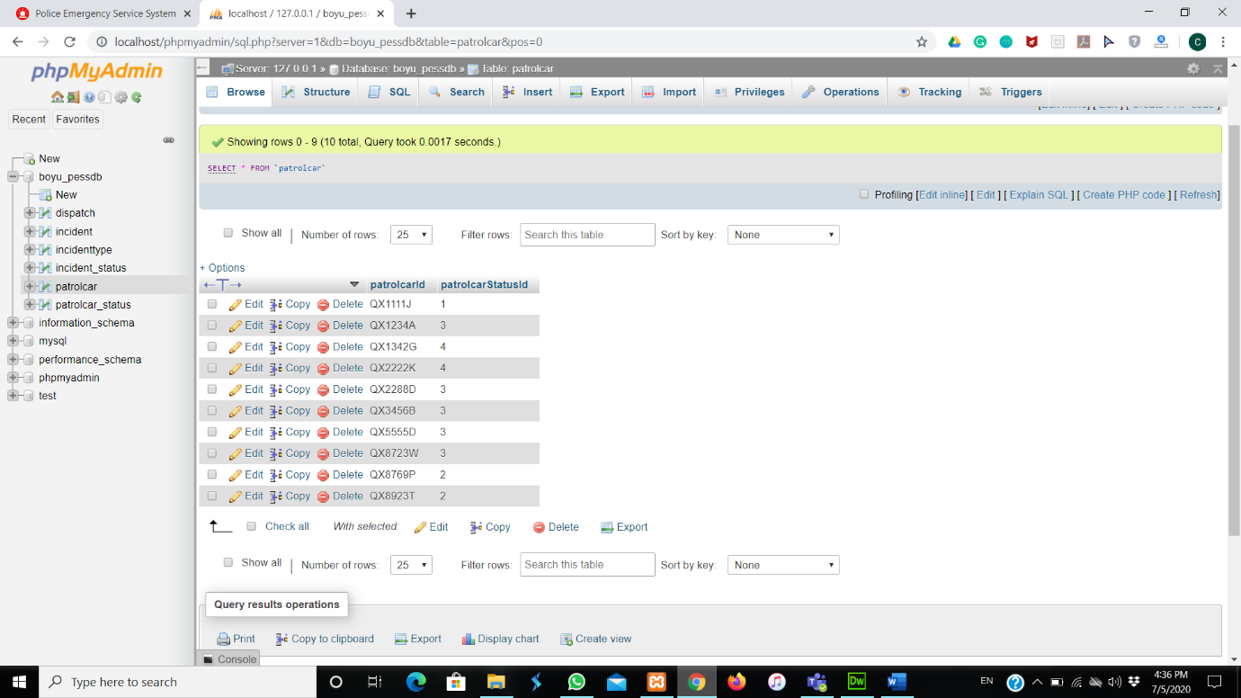**Database of patrolcar browse:**

**Update page:**

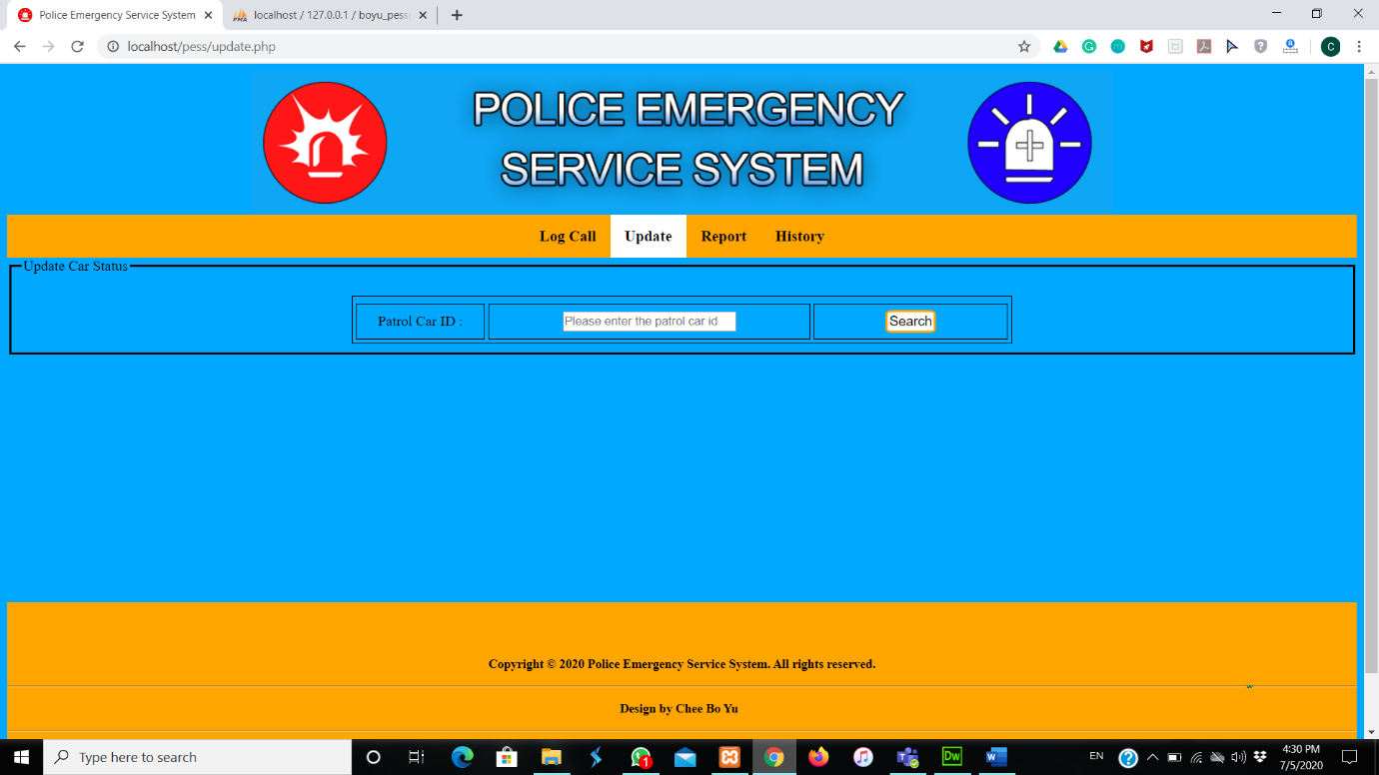

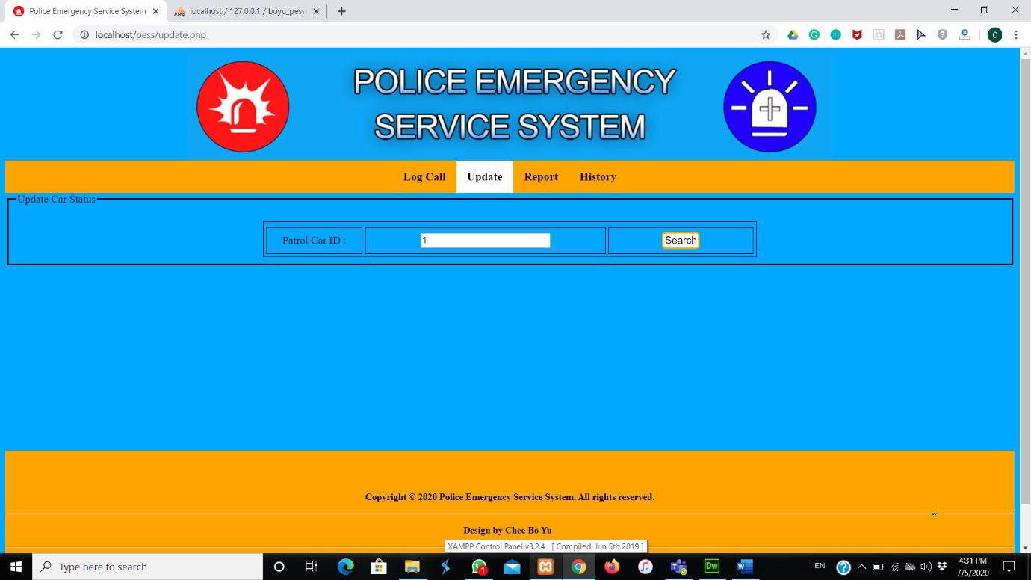**Key in invalid patrol car id:**

**Displaying error message if entering invalid patrol car id:**

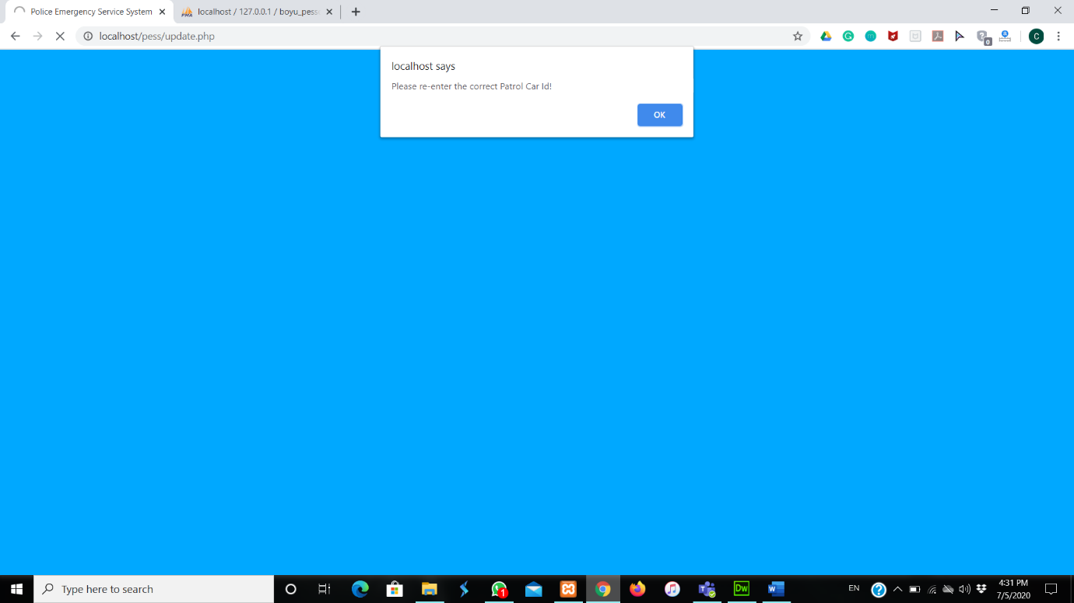

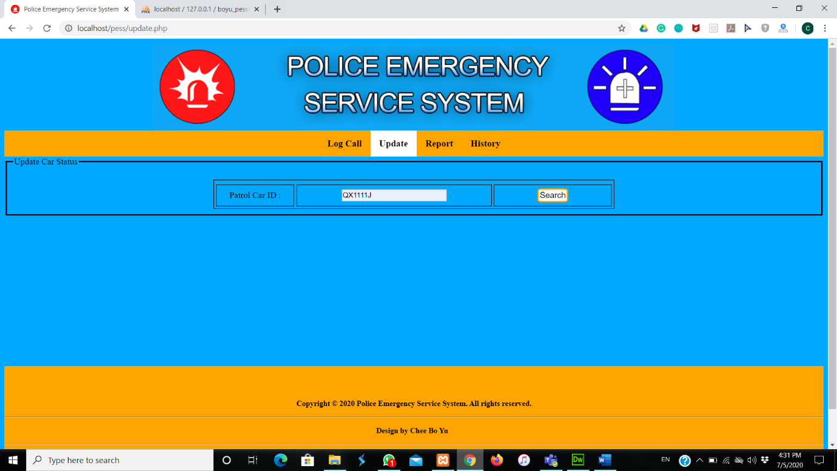**Key in the valid patrol car id:**

**The current status of the patrol car:**

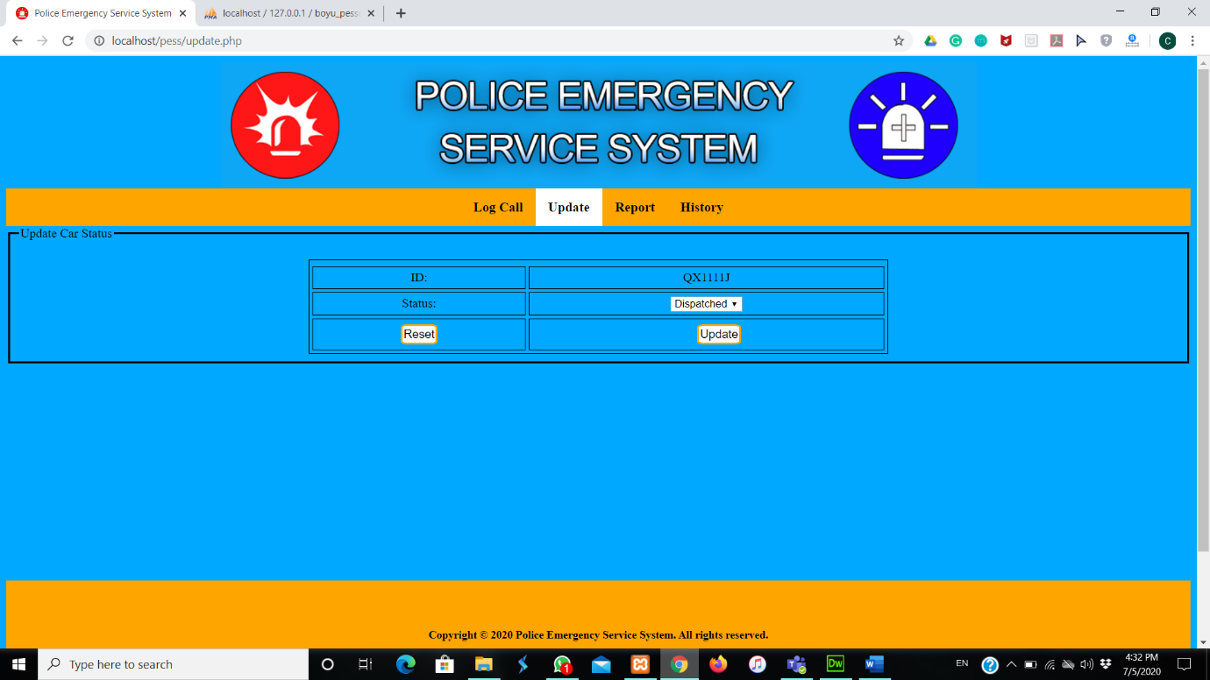

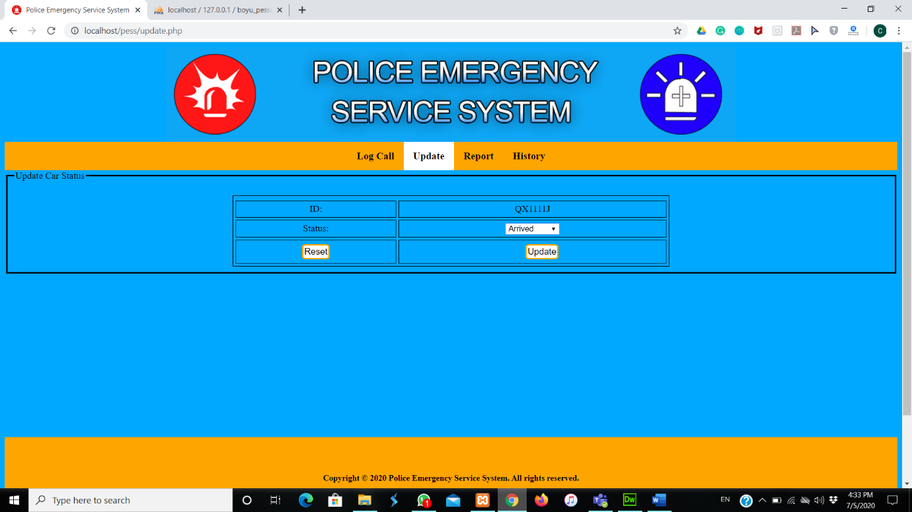**Changing the status of the patrol car to Arrived:**

**After changing the status of the patrol car, it will go to logcall page:**

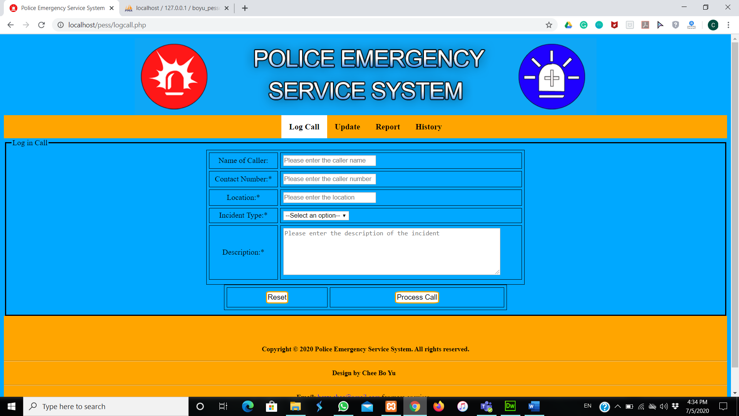

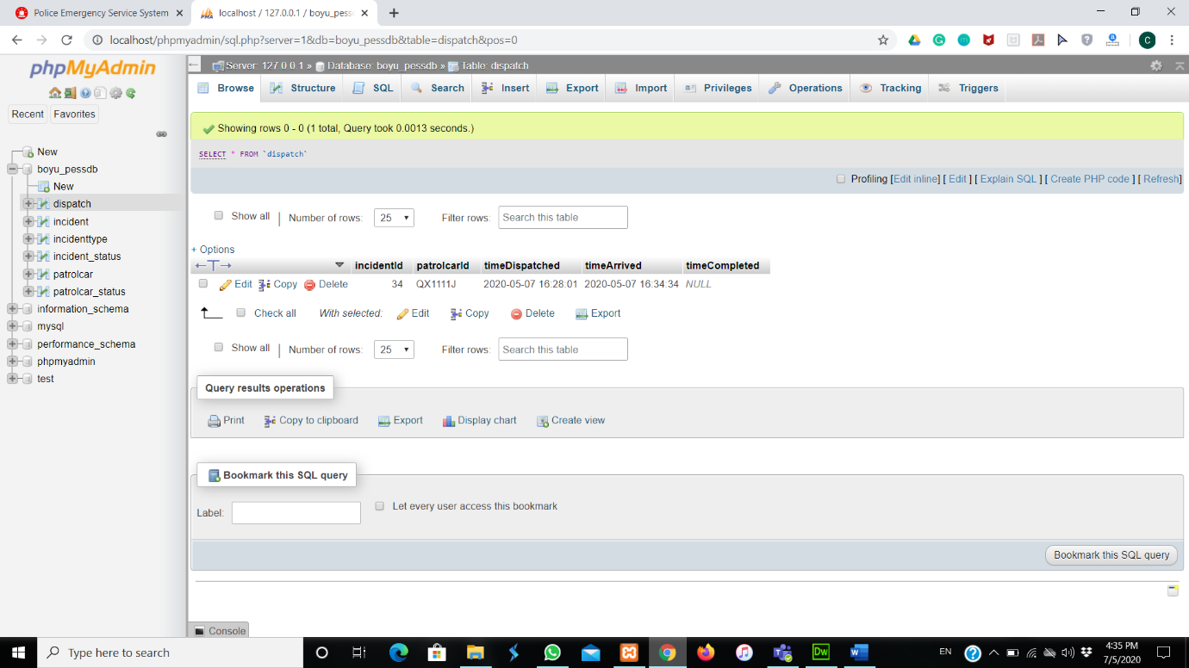**Database of dispatch browse:**

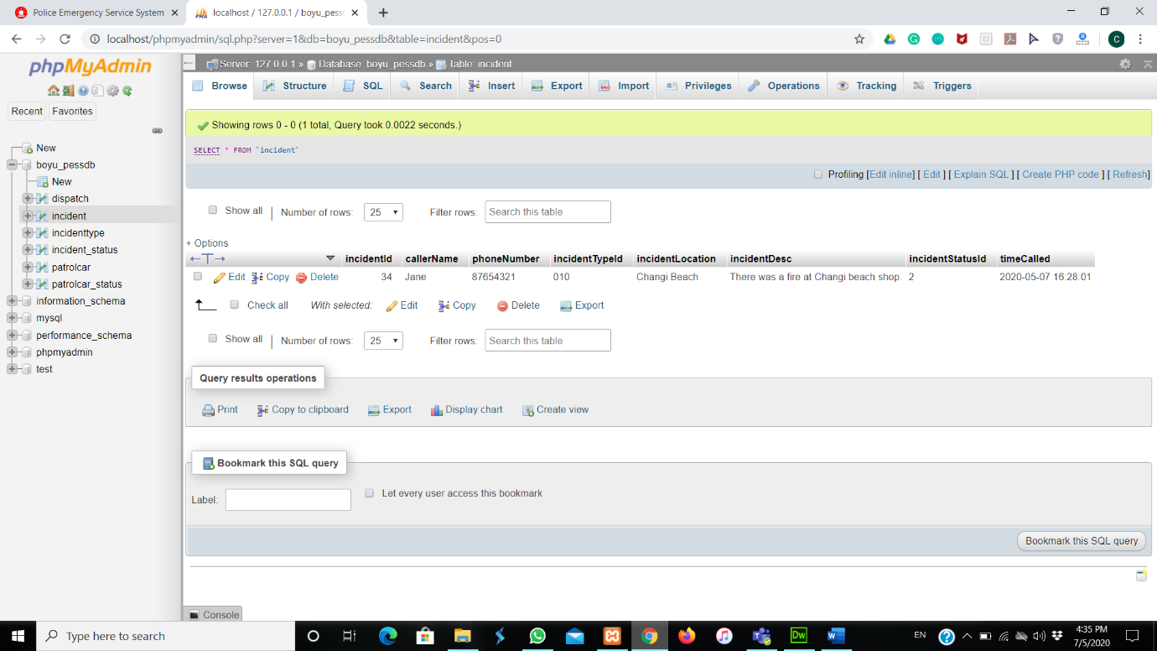**Database of incident browse:**

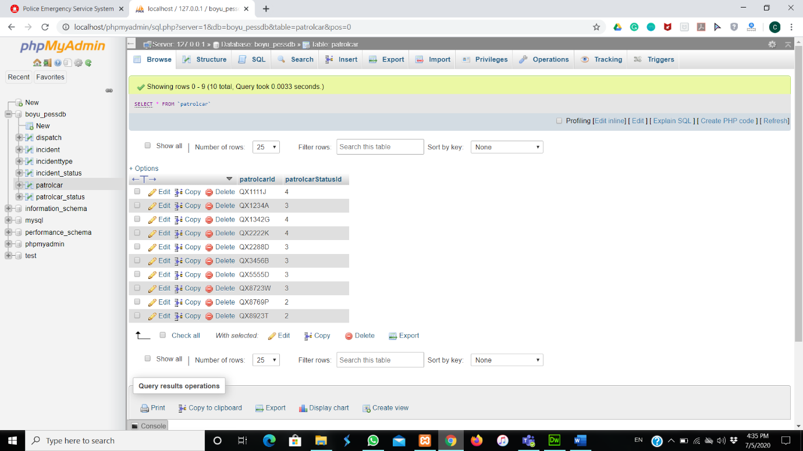**Database of patrolcar browse:**

**Key in the valid patrol car id:**

**The current status of the patrol car:**



**Status of the patrol car change to Free:**

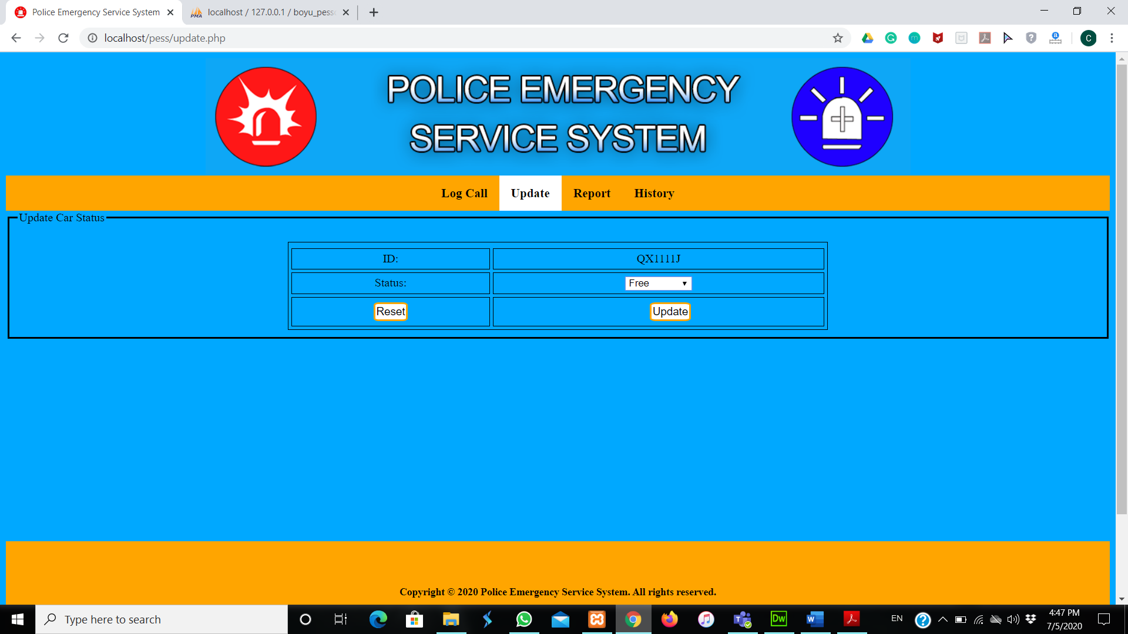

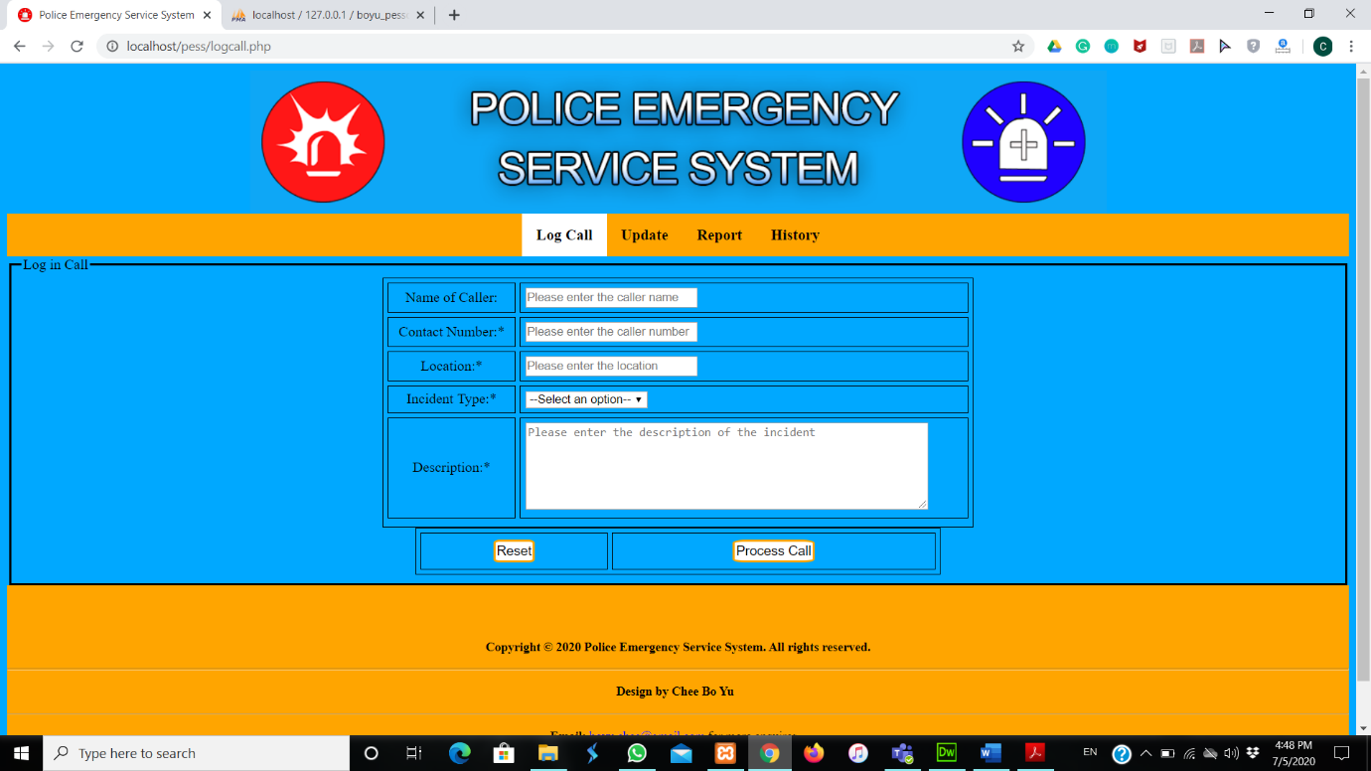**After changing the status of the patrol car, it will go to logcall page:**

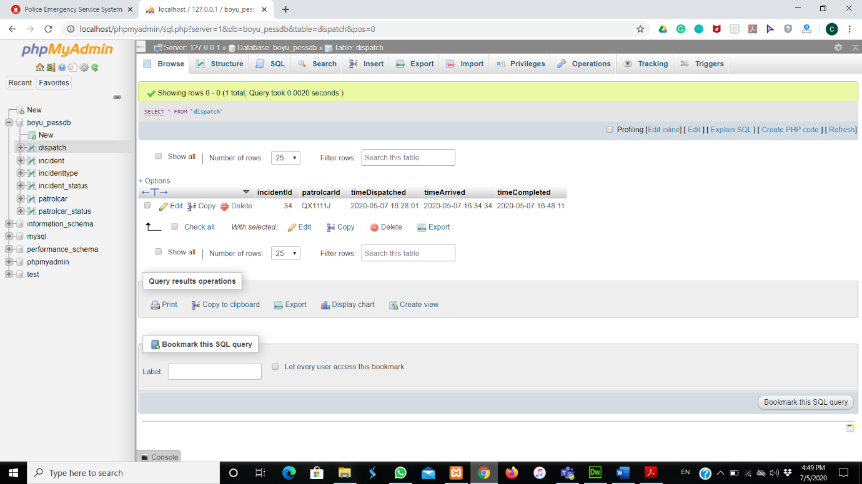**Database of dispatch browse:**

**Database of incident browse:**

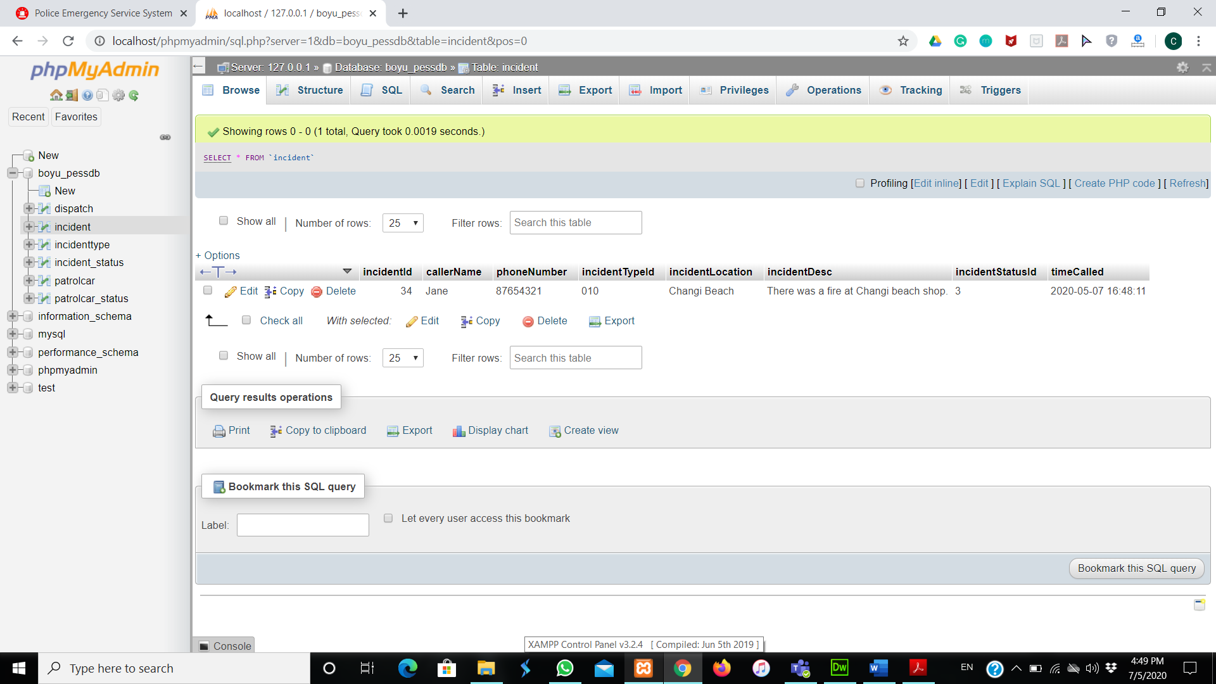

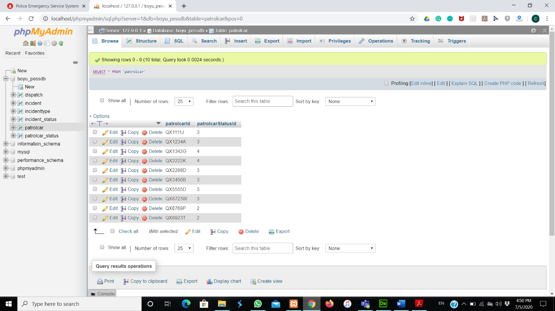**Database of patrolcar browse:**

**My file location:**

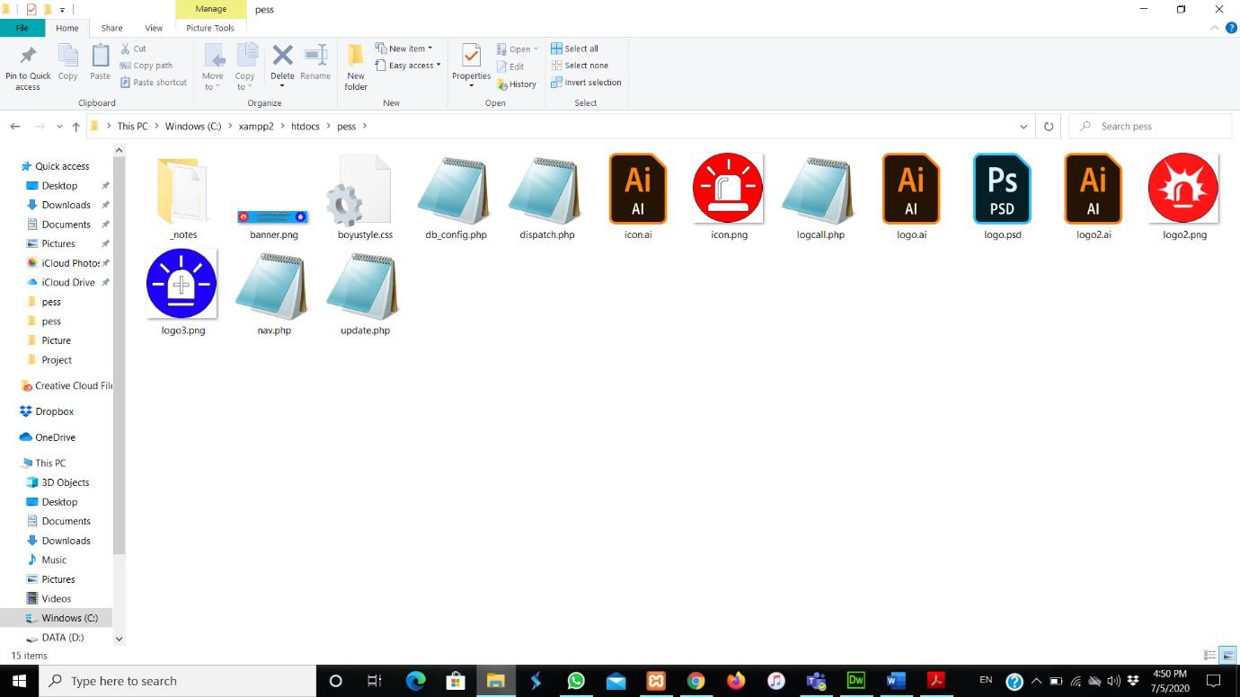

**Database of dispatch browse:**

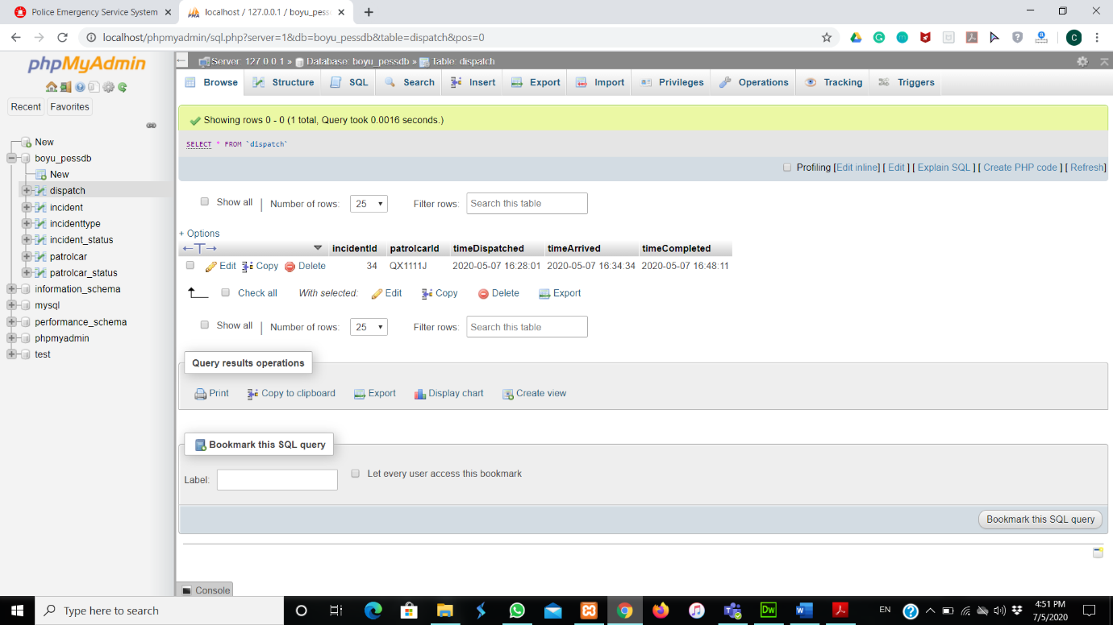

**Database of dispatch structure:**

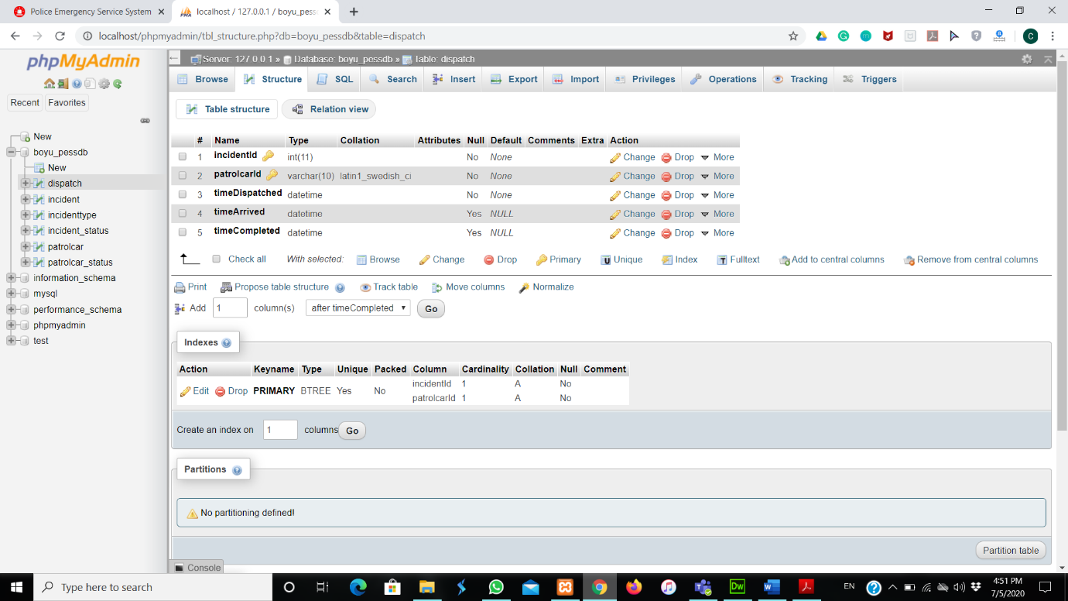

**Database of incident browse:**

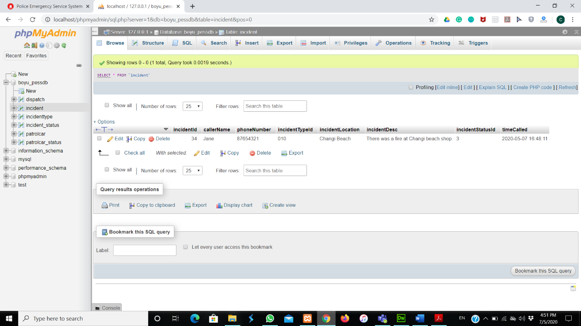

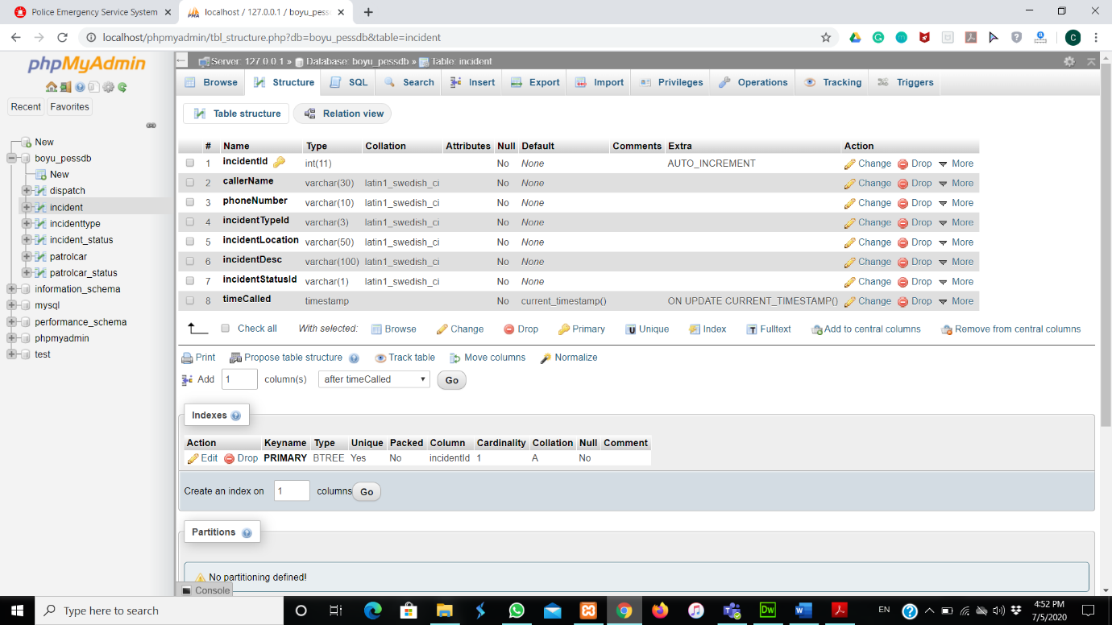**Database of incident structure:**

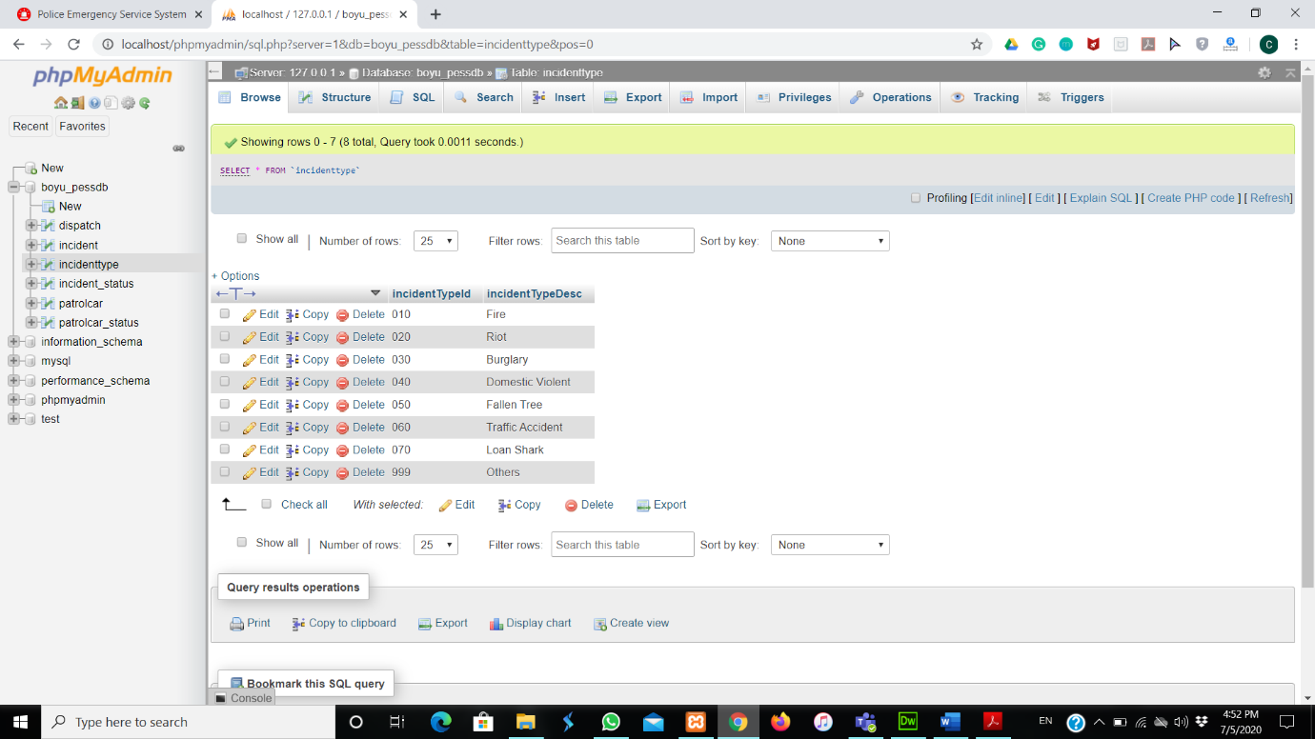**Database of incidenttype browse:**

**Database of incidenttype structure:**

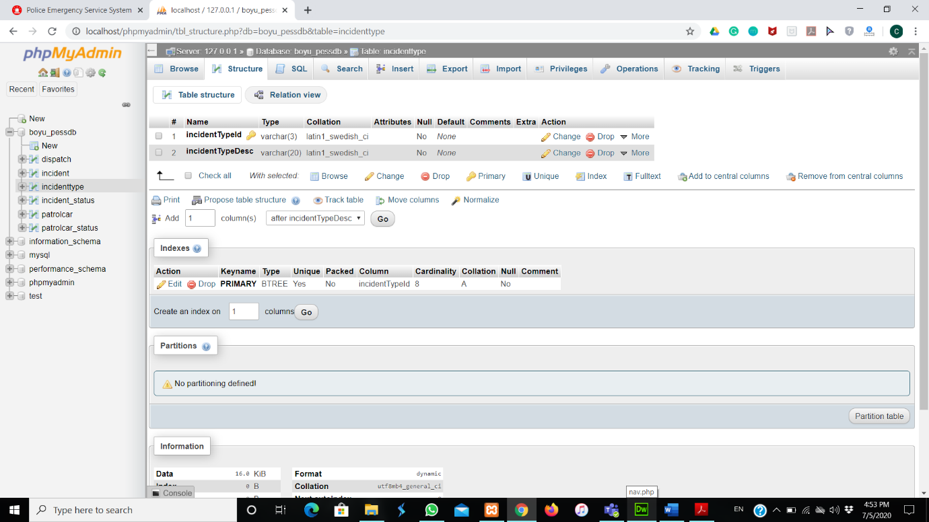

**Database of incident_status browse:**

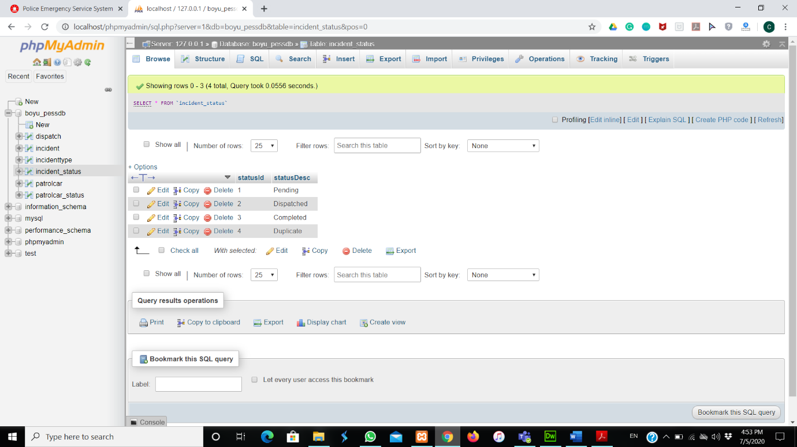

**Database of incident_status structure:**

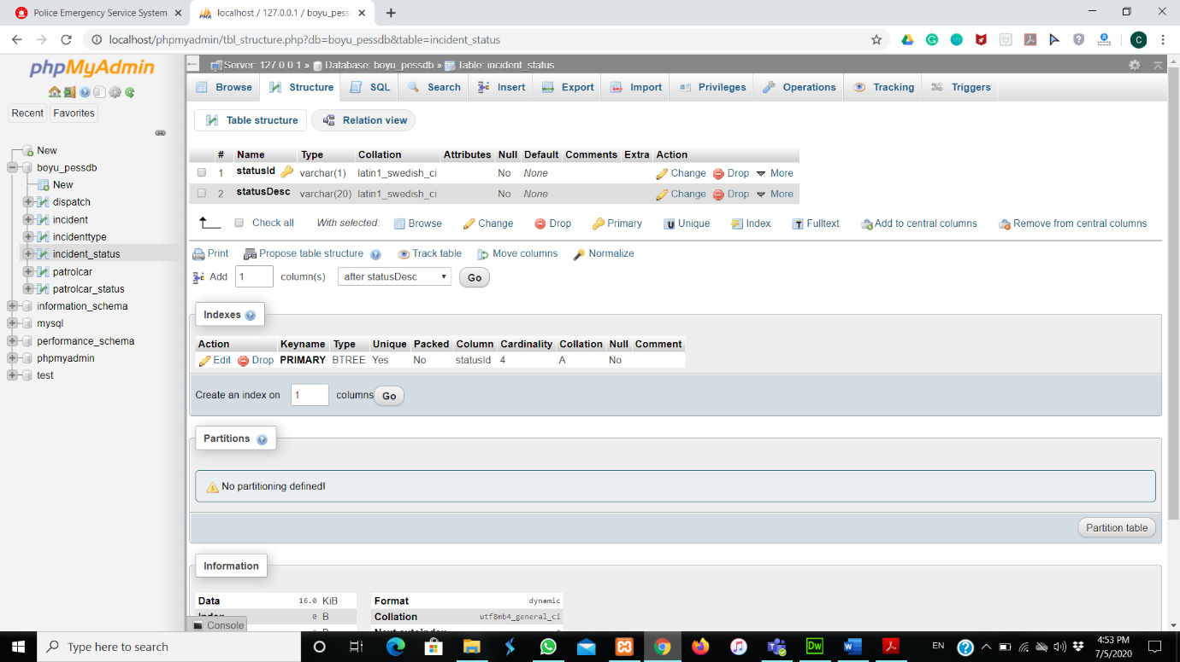

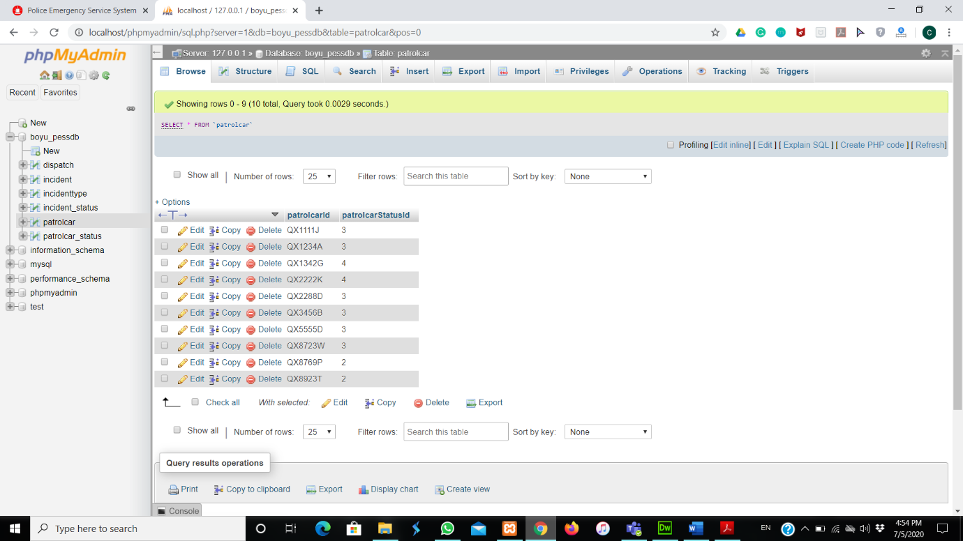**Database of patrolcar browse:**

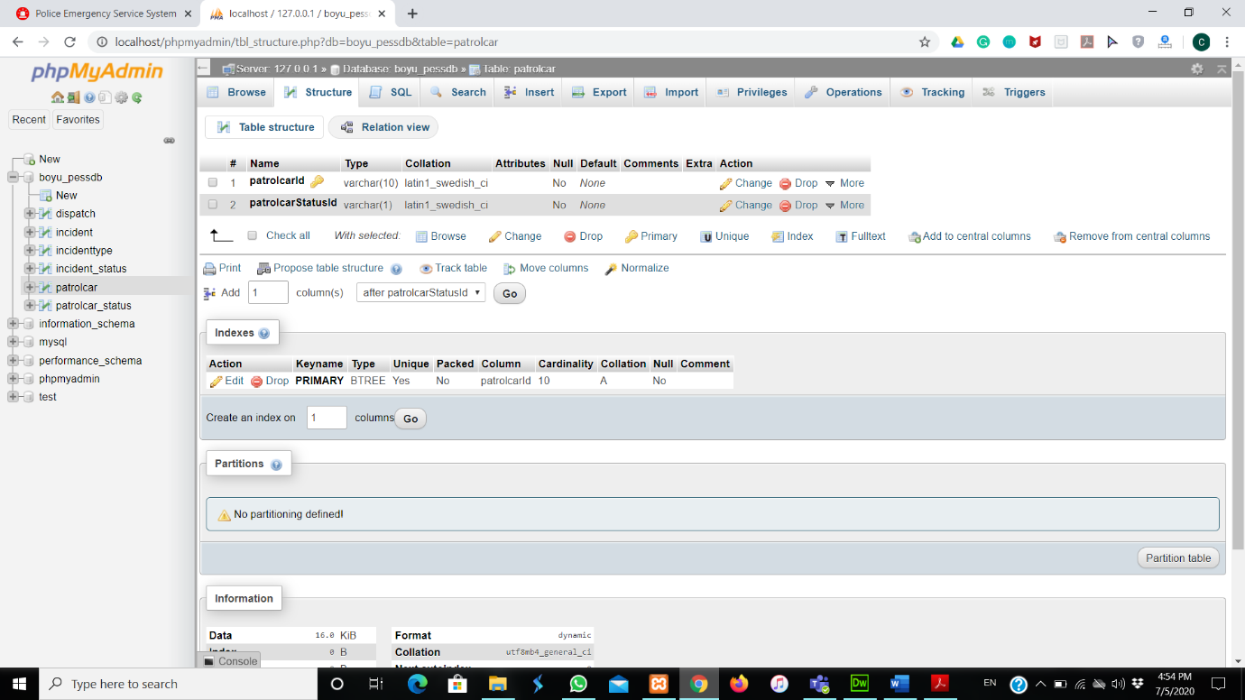**Database of patrolcar structure:**

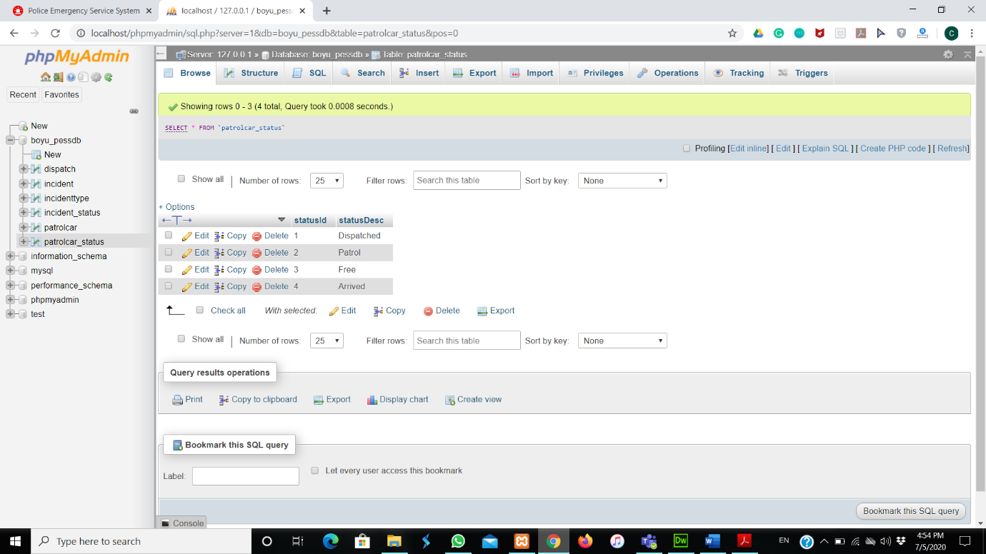**Database of patrolcar_status browse:**

**Database of patrolcar_status structure:**

